**HL Unit 7** **– Control**  
Quiz 2

|  |  |  |  |
| --- | --- | --- | --- |
| **Question 1** | | | |
| Objectives: | 7.1.1, 7.1.2, 7.1.4, 7.1.6 | Exam Reference: | May-15 12 |

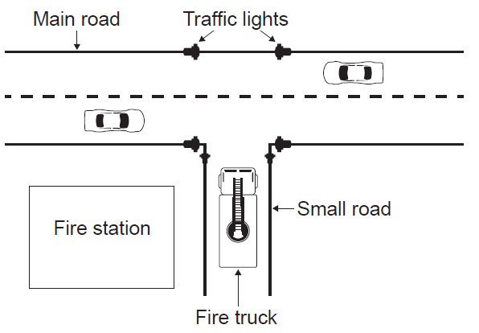  
In a town, a set of traffic lights control access from a small road, where a fire station is  
located, to a main road that has heavy traffic. In times of emergency, many vehicles from  
the fire station may need to leave the station at the same time. A system is put in place so  
that when a fire truck on the small road approaches the main road, the traffic lights switch to  
green (Go) on the small road and to red (Stop) on the main road.

1. Outline the role of sensors and a microprocessor in controlling the traffic lights in

this way. [4]

1. Suggest how the traffic lights can be changed back to their original state once there are

no more fire trucks coming from the small road. [3]

These traffic lights are controlled by embedded systems at the point of use. It is proposed  
 that they should be controlled from the same central computer as all the other traffic lights in  
 the town.

1. Discuss the advantages and disadvantages of running the town’s traffic light system

on one central computer with multiple inputs and outputs. [5]

A series of cameras are installed at each of the town’s traffic lights. These cameras are  
 connected to the central computer.

1. Discuss the social implications of monitoring traffic in this way. [3]

|  |  |  |  |
| --- | --- | --- | --- |
| **Question 2** | | | |
| Objectives: | 7.1.4, 7.1.7 | Exam Reference: | Nov-16 10 |

The temperature, humidity, light levels and automatic watering of plants inside the greenhouses (glasshouses) of a garden centre are centrally monitored and controlled.

1. Define the term analog data. [1]

1. With reference to sensors, transducers and the processor, explain the control process

hat takes place in the greenhouse (glasshouses). [5]

1. Outline the role of the operating system specific to this scenario. [4]
2. Describe the difference between polling and interrupt in the event that some of the

sensors malfunction. [3]

1. Compare a centrally controlled system with a distributed system. [2]